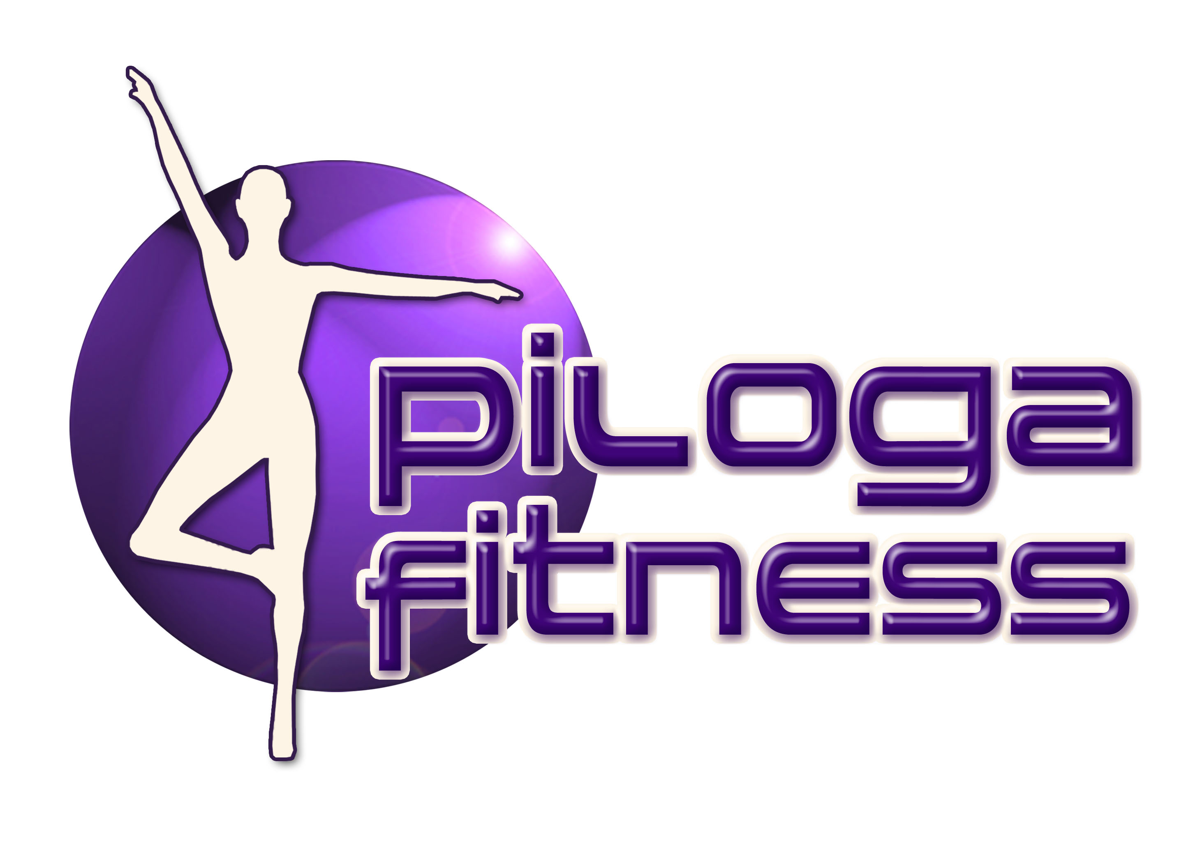
New Pilates Class

Starts: Wednesday 7th January 2015 @ 6.00pm

Pilates is a unique exercise technique that tones, strengthens and lengthens muscles to give improved flexibility and mobility and a leaner more streamlined body. It targets the deep postural muscles, building strength from the inside out, rebalancing the body and bringing it in to correct alignment. It improves posture and is a great way to relieve unwanted stress and tension. Ideal for athletes looking to improve their performance or those new to exercise, Pilates is suitable for everyone. It’s controlled approach means that it gives much longer lasting results and is also recommended by medical specialists for those with back problems.

Stott Pilates is a contemporary, anatomically based approach to the original method incorporating modern exercise principles and knowledge about spinal rehabilitation and performance enhancement. The exercises are designed to restore the natural curves of the spine and rebalance the muscles around the joints.

Karen has been practicing Pilates and Yoga for over 15 years and qualified as a Stott Pilates Instructor in 2006 and a Hatha Yoga instructor in 2010. Combining her knowledge of both disciplines and other fitness techniques Karen uses a holistic approach to design classes which are fun and stimulating whilst helping to produce optimal strength and flexibility.

Contact Karen for more information on:
07599 619914 or karen@pilogafitness.co.uk or visit: www.pilogafitness.co.uk

